AIR BADMINTON Croatian International 2024

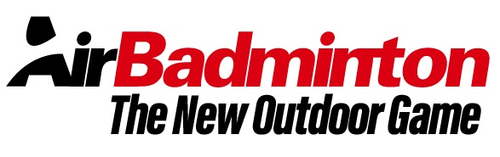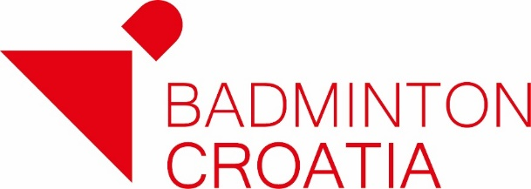

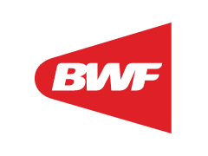 CROATIA, Adriatic sea, Ičići, Beach Ičići, 24 August 2024.

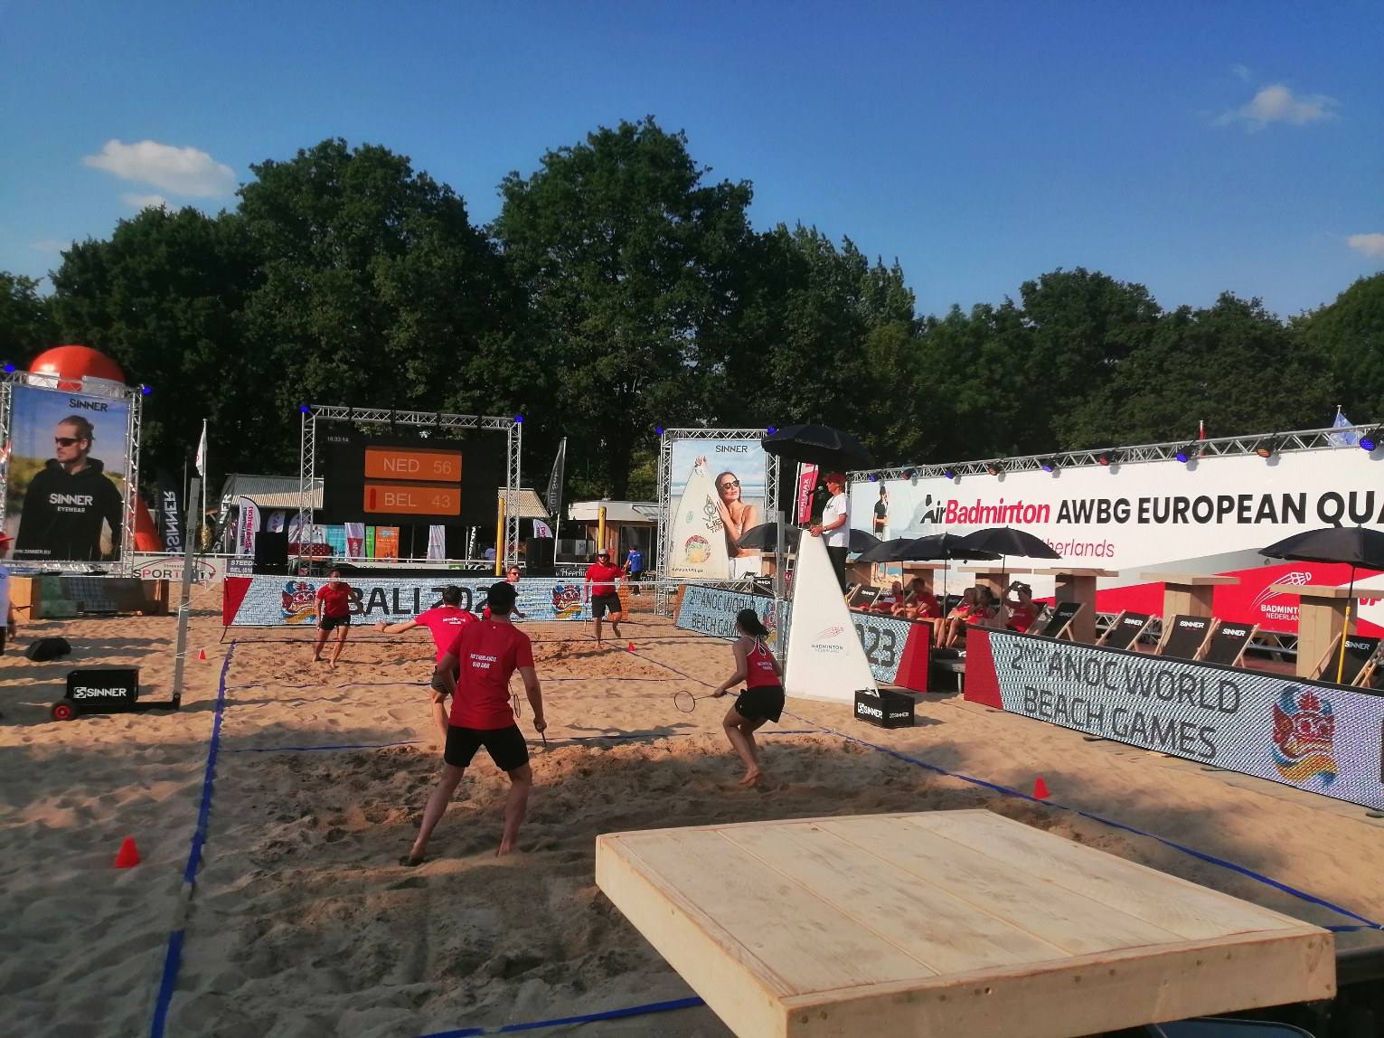
CLOSING DATE: 15. August 2024.



SPORT, SEA, SUN is the TOP FUN

ORGANIZER
Croatian Badminton Association
Badminton club Stella, 10020 Zagreb, Croatia, Remetinečka 77a &
KŠR Gorovo, 51410 Opatija, Andrije Štangera 48

Tournament Director: Mr. Željko Miškulin
Executive director / Contact person: Mrs. Tatjana Zrnić; Phone: +385 91 72 71 302
Tehnical director / Mr. Dalibor Korenić
e-mail: info@crointer.com; www.crointer.com

REFEREE
Damir Ilić, (Croatia); Phone: +385 99 531 23 98; e-mail: damir_ilic@yahoo.com

VENUE
Beach Ičići, 51414 Ičići, Liburnijska ulica 9 – 11

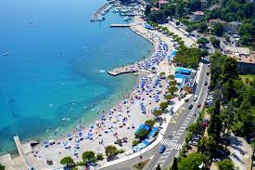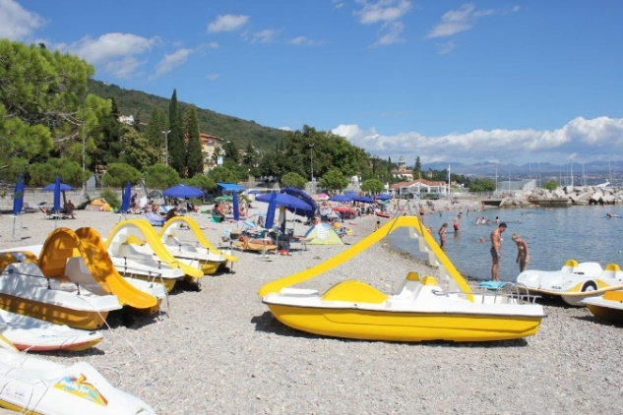

PROVISIONAL SCHEDULE
Saturday, 24 August 2024 - 09:00 Main rounds
Saturday, 24 August 2024 - 15:00 Quarter-finals; 16:00 Semi-finals
Saturday, 24 August 2024 - 17:00 Finals

NOTICE:
I case of bad weather, which is possible in summer time, the tournament will be held on August 25, 2024. (Sunday).
The final frame schedule be published on the organiser’s website.

EVENTS
Doubles (with two players per side), triples (with three players per side)
Team: men, women or mix
CLOSING DATE : Thursday, 15. August 2024.

SPORT, SEA, SUN is the TOP FUN

ENTRIES

online entries via tournament software link

https://www.tournamentsoftware.com/tournament/4B5447D8-6696-4193-9547-C8E7D7720416

or

Badminton club Stella, ENTRY FORM document sent to:
E-mail; info@crointer.com;

PRIZE MONEY

Doubles: 1. team 80,00 EUR 2. Team 40,00 EUR
Triples: 1. team 100,00 EUR 2. Team 60,00 EUR

Lottery prize money is: 60,00 EUR – 1 prize/1 team

all team have their number and drawing a number the winner is determined. Raffle system is attractive for all competitors and has a relaxing effect, because everyone has a reason to be hopeful and cheerful. A good way to advertise the tournament and the sport would be to include major betting odds for final matches.

BENEFITS

- Gratis T shirt
- Free fruits and water, for all tournament participants
- Good prize money
- Raffle prizes
- Free Blackbaminton - Karaoke party and Players party for participants
- Entertainment attractiveness at the tournament
- Good transport with other cities and countries
- SPORT, SEA, SUN is the TOP FUN

SHUTLLES

- VICTOR AS AIRSHUTTLE
COURTS
- 3 VICTOR AIR BADMINTON court

ENTRY FEES
- doubles team: € 40,00/per team
- triples team: € 60,00/per team

PAYMENTS
Payable on our bank account or in cash at the info desk on Beach Ičići during the first competition day or before tournament to:

Badmintonski klub Stella, Remetinečka cesta 77a, 10000 Zagreb, Croatia

Privredna banka Zagreb d.d.

IBAN: HR 83 23400091110035986 SWIFT: PBZ6HR2X MBK: 786240

ACCOMMODATION – cheapest prize – plan and book on time!!

Hostel Lumber
51415 Lovran, 43. Istarske divizije 3.
E mail: dom@ucenicki-dom-lovran.hr
Phone: +385 51 292 444

Hostel Link
51415 Lovran, Šetalište marsala Tita 9.
E mail: info@linkhostel.com
Phone: +385 51 202 090

Accommodation have to be reservation and paid on the reception desk at the Hostel.
PLAYERS PARTY:
After the competition Players party and Karaoke Party will be organized – Welcome AIR Badminton friends on Ičići beach with DJ

DISTANCE

Budapest 520 km, Milano 477 km, Munchen 518 km, Wien 493 km, Ljubljana 112 km,

SPORT, SEA, SUN is the TOP FUN

